Miami Alumnae Chapter - Delta Sigma Theta Sorority, Inc.

2019-2020

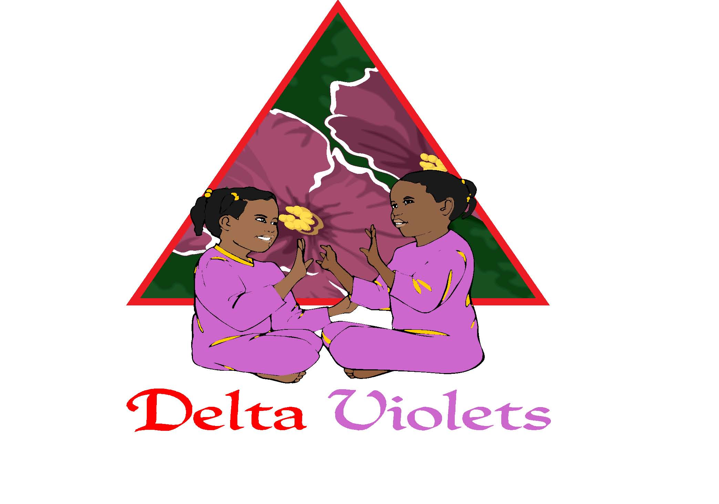

APPLICANT INFORMATION

NAME: ________________________________________________________ DATE_______________
Last First M.I.

ADDRESS: ____________________________________________________________________________
Street Address Apt/Suite #
______________________________________________
City ZIP Code

HOME NUMBER: (___) ____- ______ CELLULAR NUMBER: (___) ___-______ ALT NUMBER: (___) ____- _______

EMAIL ADDRESS: _________________________________________________________

DATE OF BIRTH: ______ / ______ / ___________
(mm) (dd) (yyyy)

PARENT/GUARDIAN NAME: ___________________________________________________________
Last First M.I.

CONTACT NUMBER: (___) _____- _________ ALT NUMBER: (___) _____- _______

EMAIL ADDRESS: ________________________________________________

EMERGENCY CONTACT: _________________________________________________________
Last First M.I.

CONTACT NUMBER: (___) ____-_______ ALT NUMBER: (___) ____- _______

EMAIL ADDRESS: _______________________________________________

DEMOGRAPHICS
RACE (PLACE A CHECK NEXT TO THE RACE THE APPLICANT IDENTIFIES WITH MOST)
❒ White (Non-Hispanic)  White (Hispanic/Latina) Black (Non-Hispanic)
❒ Multi-Racial/Multi-Ethnic

HOUSEHOLD SIZE (PLACE A CHECK NEXT TO THE HOUSEHOLD SIZE)
❒ 3 or LESS  4 – 7  8 – 12  ABOVE 12

RESIDENTIAL CITY/NEIGHBORHOOD (PLACE A CHECK NEXT TO THE CITY/AREA WHICH THE APPLICANT RESIDES)
❒ Allapattah/Wynwood  Aventura  Biscayne Park  Cutler Bay  Miami Gardens
❒ City of Miami  North Miami  North Miami Beach  South Miami  Coconut Grove
❒ Kendall  Homestead  Goulds  Opa-Locka  Princeton
❒ Florida City  Miami Lakes  Doral  Miami Lakes  Miami Shores
❒ Sweetwater  Hialeah  Hialeah Gardens  Perrine  Little River
❒ Miami Springs  Miami Beach  Un-incorporated Miami-Dade County
❒ Other: _____________________________

ALLERGIES

DRUG ALLERGIES: ___________________________________________________________________
_________________________________________________________________________________

FOOD ALLERGIES (i.e. watermelon, peanuts, etc): __________________________________________
_________________________________________________________________________________

SUBSTANCE ALLERGIES (i.e. dust, pollen, etc): _____________________________________________
_________________________________________________________________________________

ANIMAL ALLERGIES (i.e. dogs, cats, etc):__________________________________________________
_________________________________________________________________________________

HOBBIES

HOBBIES: (CHECK ALL THAT APPLY)
COOKING SINGING DANCING STEPPING CHEERLEADING
PARTY-PLANNING SHOPPING READING OTHER: __________________________________

EDUCATION

ELEMENTARY SCHOOL

School: ___________________________________________________

GRADE LEVEL

Grade: ____________________________________

FAVORITE SCHOOL SUBJECTS
(PLEASE CHECK ALL THAT APPLY)
Language Arts/Reading Social Studies Math Art
Science Music Physical Education
Other: _____________________________

VIOLET’S FAVORITE

FOOD___________________________________ COLOR___________

PLEASE SIGN BELOW. YOUR SIGNATURE WILL INDICATE THAT YOU AND YOUR VIOLET
HAVE READ, UNDERSTAND AND WILL ADHERE TO ALL OF THE ITEMS IN THIS PACKET

_______________________________________ _______________
PARENT/GUARDIAN SIGNATURE DATE

_______________________________________ _______________
VIOLET’S NAME DATE

ORIENTATION –09/11/19
Booker T. Washington Sr. High School
2019-2020 Delta Violet Contacts
Ms. Angelisha Tanechie Davis, Chair
Ms. Tiffany Simone Nelson, Co-Chair
deltaviolets@dstmiami.org

EMERGENCY CONTACT INFORMATION
Parent/Guardian #1
Name________________________________________________Relationship______________
Street Address__________________________________________________________________
City___________________________ State ______________Zip Code ____________________
Home Phone_______________ Work Phone __________________Cell Phone ______________
E-mail address__________________________________________________________________
Parent/Guardian #2
Name________________________________________________Relationship______________
Street Address__________________________________________________________________
City___________________________ State ______________Zip Code ____________________
Home Phone_______________ Work Phone __________________Cell Phone ______________
E-mail address__________________________________________________________________
If for any reason I/we cannot be reached, please contact the following person(s) whom I/we
hereby authorize to seek emergency medical or surgical care for my/our child.

Name: _____________________________________ Relationship to Student _______________
Home Phone_____________ Work Phone ______________ Cell Phone __________________
Name: ____________________________________ Relationship to Student _______________
Home Phone_____________ Work Phone ______________ Cell Phone __________________
In the event that the Program is unable to reach any of the individuals named above promptly by phone, I/we authorize the Program to seek and secure any emergency medical or surgical care for my/our child. I/We will be responsible for any and all expenses incurred and authorize the medical facility at which treatment is rendered to release all necessary information to my/our insurance company.

Parent/Guardian Signature _______________________________________Date_____________
Parent/Guardian Signature _______________________________________Date ____________

DELTA VIOLET-PARENT-MENTOR CODE OF CONDUCT

Miami Alumnae Chapter seeks to provide a safe and exciting atmosphere for girls to learn more, explore new things, grow in weak areas and most importantly be free to be themselves. Please read below and sign this form.

As a Violet, I will
- Be RESPECTFUL to myself, my peers, family and adults
- Use appropriate language and tone with others
- Be helpful, clean, honest and kind at ALL TIMES
- Be ON TIME to meetings and events
- Complete my take home activities and have fun doing them
- Resolve conflict peacefully with the help of the Delta Violet Mentors
- BE THE BEST VIOLET I CAN BE

As a Parent, I will
- Bring my Violet REGULARLY to all meetings and events. If this cannot occur, I will notify the appropriate mentor in advance
- Drop off and Pick Up my Violet ON TIME from all meetings and events.
- Assist my Violet with completing all fun take home activities
- Be respectful of those volunteering their time as mentors, respectfully bringing all concerns and comments to Delta Violet Mentors
- Abstain from posting pictures/photo/video of other Violets, Mentors and Parents on social sites (i.e. facebook, my space, you tube, etc.)
- Refrain from bringing guests/relatives to closed events & meetings without prior approval

As Mentors, we will
- Be ON TIME to meetings and events
- Provide ample notification of calendar changes (at least 5 days)
- Respectfully bring concerns and comments to Parents and Violets
- Keep information about Violets confidential
- Use pictures/photos/video of meetings and activities for Chapter use only
(i.e. website, recruitment flyers)

I am excited to join Delta Violets and I look forward to all the wonderful experiences ahead. By signing below I agree to fulfill my responsibilities:

With my parent or other adult, I have read the Code of Conduct and sanctions for violating the
Code. I understand the Code and the sanctions. I will follow the Code of Conduct.

As a Violet ____________________________________________________________
Print Name

**************

I have read and understand the Code of Conduct and sanctions for violating the Code of Conduct.
I understand that my child’s compliance with the Code of Conduct is a condition of her/his
participation in the Delta Violets program. I agree that the sanctions for violating the Code of
Conducts are reasonable and will help my child comply.

__________________________________ ______________________________
Parent - Print Name Signature

Date______________________________

YOUTH PICK-UP AUTHORIZATION FORM

I authorize the persons listed below to pick-up my child from the Delta Violets youth initiatives program. For my child’s safety, I understand that all authorized persons on the list below will be asked to show photo identification before my child is released to them; therefore, I will notify all authorized persons of this requirement so that they will have photo identification with them when they arrive to pick-up my child. (Please include names of either parents or guardians on list below).

Name _________________________________________ Relationship_____________________

Home Phone_____________ Work Phone ______________ Cell Phone __________________

Name _________________________________________ Relationship_____________________

Home Phone_____________ Work Phone ______________ Cell Phone __________________

Name _________________________________________ Relationship_____________________

Home Phone_____________ Work Phone ______________ Cell Phone __________________

Name _________________________________________ Relationship_____________________

Home Phone_____________ Work Phone ______________ Cell Phone __________________

Name _________________________________________ Relationship_____________________

Home Phone_____________ Work Phone ______________ Cell Phone __________________

By signing below, I verify that I have read and agree to the Student Pick-Up policies described
above and authorize the Miami Alumnae Chapter to release my child to the persons listed above. I also agree to notify the Miami Alumnae Chapter in writing of any changes to the above list of authorized persons.

Mother/Guardian Signature ___________________________________Date _______________

Father/Guardian Signature ____________________________________Date _______________
Violet’s Name: ___________________________________________________

PHOTOGRAPH AND VIDEO AUTHORIZATION AND RELEASE FORM

Dear Parent or Guardian:

Please be advised that during this year your child may be photographed, videotaped, or interviewed during the various activities or events. With your consent, the photograph, video, or interview may be reproduced and released for use of the sorority, newspaper or brochures.
Please indicate below:

Violet’s Name: __________________________________________________

________ Yes, my child’s photograph/video/interview may be reproduced for use by the sorority.
________No, my child’s photograph/video/interview may not be reproduced and released for use by the sorority.

_________________________________________________ ____________________ Parent’s Signature # 1 Date

_________________________________________________ ____________________
Parent’s Signature # 2 Date



